GGN - Geopark Annual Report 2018

1. GEOPARK IDENTITY
Geopark name, country, regional Network: Tianzhushan UNESCO Global Geopark (P.R.China, APGN)
Year of inscription / Year of the last revalidation:2011/2015
Representative Photo (from the most important event this year)
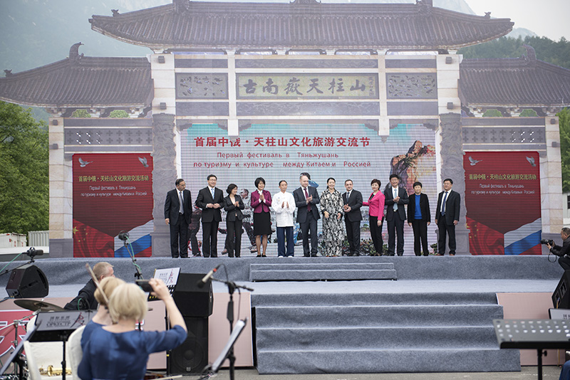
2. GEOPARK FIGURES
Number of Geopark staffs: 235 staffs including 6 geoscientists
Number of Visitors: 1.402 milllion person times
Number of Geopark events: 18
- In January, Tianzhushan organized China (Tianzhushan) Travel Agencies and Multi-media Conference;
- In April, Tianzhushan held the first Sino-Russia Tianzhushan Culture and Tourism Exchange Activity;
- In April, Tianzhushan held a series of science popularization activities on World Earth Day, including geoscientific popularization lecture in Tianzhushan Primary School, a study training meeting for staffs of Tianzhushan Administrative Committee, itinerant science popularization exhibition with the theme: Pay attention to the climate change and advocate low-carbon lifestyle, and a painting competition in Meicheng Primary School on World Earth Day, among others.
- In April, Tianzhushan held the first Tianzhushan azalea tourism festival;
- In May, together with University of Science and Technology of China, Tianzhushan co-held the 19th National Seminar on Inclusion and Geofluid and 2018 Advanced Seminar on Magmatic Rocks in Subduction Zones, after which a post-conference field trip was held in Tianzhushan Geopark, further improving the reputation of Tianzhushan.
- In May, Tianzhushan held “520” large-scale blind date and Anhui-Jiangsu-Hubei-Henan youth fellowship;
- In June, Tianzhushan issued and implemented Planning of Tianzhushan National Geopark (2014-2028);
- In September, Tianzhushan gave a science popularization lecture in Anqing Normal University entitled The Geoheritage of Tianzhushan UNESCO Global Geopark—Telling the Earth’s Story, made by Professor Wu Weiping.
- In September, Tianzhushan issued and implemented Regulations on Anqing Tianzhushan Scenic Area;
- In September, Tianzhushan held China (Tianzhushan) International Longboard Downhill Competition 2018, during which an investment promotion and tourism promotion conference was held;
- In October, Tianzhushan held 2018 China (Tianzhushan) International River-tracing Cross-country Challenge and National Skyrunning Contest, during which a culture and tourism promotion conference was held;
- In October, Tianzhushan held 2018 The First China (Qianshan) International Culture Art Exchange Activity on Ancient Doumu Pottery;
- In October, Tianzhushan set up Qianshan City (Tianzhushan) Culture Tourism Association;
- In October, Tianzhushan gave folk custom performances during National Day;
- In October, the final competition of square dancing of Jiangsu Province was successfully held in Tianzhushan;
- In November, Tianzhushan co-organized the 16th academic annual meeting of Chinese Society of Vertebrate Paleontology;
- From November to December, science popularization lectures were respectively given in Anqing No.1 Middle School and Tianzhushan Tourism School;
- In December, Tianzhushan cooperated and signed a contract with Huaqiaocheng Group.

Number school classes realize Geopark educational programmes: 16
Number of Geopark press release: 102

3. GEOPARK ACTIVITIES
Major achievements in 2018
- The main project of Tianzhushan Geomuseum was completed in an all-round way;
- The thunder prevention project was completed and put into operation;
- The third-phase Smart Park project was promoted orderly;
- Tianzhushan Biodiversity Project was implemented;
- The environmental data real-time monitoring system was constructed, including five real-time monitoring points;
- Villages, towns as well as peasant households within the geopark got help, including 579 peasant households.

Contribution towards GGN - Networking and Participation
- In March, the geopark attended the International Seminar on Geological Landscape and Culture Integrative Development held by Jiuhuashan National Geopark;
- In July, the geopark representatives made exchange activity in Sanqingshan UGGp;
- In August, the geopark established sister geoparks with Sanqingshan UGGp;
- In August, the geopark representatives attended the Asia-Pacific Geoparks science popularization summer camp activity held by Fangshan UGGp;
- In August, the geopark representatives attended the special workshop on evaluation and revalidation of UGGps held in Beijing;
- In September, the geopark representatives attended the 8th international conference on UNESCO Global Geoparks in Adamello Brenta UGGp, Italy, and gave an oral presentation entitled The Protection and Inheritance of Doumu Pottery Handcraft in Tianzhushan UGGp;
- In September, the geopark established sister geoparks with Terra Vita UGGp in Germany;
- In November, the geopark representatives attended 2018 annual meeting of Chinese Global Geoparks held in Yandangshan UGGp;
- In November, the geopark representatives attended the 4th International Training Course on UNESCO Global Geoparks (Beijing).

Management and Financial status
Management Structure: Tianzhushan Global Geopark Administrative Committee, 10 staffs were newly recruited
Financial Status: the financial status is in good situation with ticket income of 110 million yuan and over 50 million yuan invested on the geopark management and construction.

Geoconservation
1. 735 workdays in field patrols and 860 workdays in community promotion;
2. 35 geoheriage maintainer volunteers were developed;
3. The geopark made comprehensive patrol and protection twice for geosites in southern scientific investigation area, changed ten geoheritage interpretive panels and cleared weeds in Hanchangchong geosite, Yangxiaowu fossil site and Xudawu fossil site;
4. County, Village and Town three-level forest chief and river chief system was established to comprehensively protect the eco-environment of the geopark.

Sustainable tourism (Geotourism)
In 2018, Tianzhushan geopark totally received 1.105 million person times, developed more than 380 agritainments, possessed 11,000 beds, more than 100 tourism shops, and achieved comprehensive geotourism income of 650 million yuan, which promoted the development of agriculture, forestry, service industry, handicraft producing and cultural industry.

New Education programmes on geoconservation, sustainable development and disaster risk reduction
Tianzhushan geopark held science popularization activities during April 22nd World Earth Day and June 5th World Environment Day, completed 8 geoscientific lectures with more than 500 students, and participated in the council meeting of Anqing Teenagers Science Education Association.

Strategic Partnership
In May, together with University of Science and Technology of China, Tianzhushan co-held the 19th National Seminar on Inclusion and Geofluid and 2018 Advanced Seminar on Magmatic Rocks in Subduction Zones.
In November, Tianzhushan co-organized the 16th academic annual meeting of Chinese Society of Vertebrate Paleontology, after which a post-conference field trip was held in Tianzhushan Geopark, further improving the reputation of Tianzhushan.

Promotional activities
The geopark continued to promote Tianzhushan on CCTV together with other Anhui provincial organizations, cooperated with CCTV to shoot and broadcast feature films, added Tianzhushan to the Weather Forecast broadcast at the end of Anhui TV News, developed strategic cooperation with China Tourism and Anhui Daily to promote publicity columns. The high-speed trains on Beijing-Fuzhou Railway, Shanghai-Wuhan Railway and Nanjing-Anqing Railway are named as “Tianzhushan, Qianshan, Anhui”. Tianzhushan promotion advertisements were launched in Hefei high-speed rail station, subway station, expressway entrance, service areas and on the public buses of Hefei, Nanjing and Wuhan cities. The geopark also successfully held tourism forums and promotion conferences in Fuyang, Bengbu, Nanjing, Changsha, Changde, Wuhan, Nanchang and Jiujiang cities, among others.

4. Contacts:
Manager: Wang Chendong tzsgeopark@126.com
Scientific Responsible (Geologist): Wu Weiping 962745352@qq.com
Wang Yuanqing wangyuanqing@ivpp.ic.cn

